create table student(

reg_no int primary key,

name varchar(25),

comp int,

math int,

sci int,

tot int,

check(comp between 0 and 100),

check(sci between 0 and 100),

check(tot between 0 and 100));

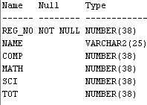

insert into Student(reg_no,name,comp,math,sci) values(1,'Anandu',78,89,96);

insert into Student(reg_no,name,comp,math,sci) values(2,'Ankit',90,88,79);

insert into Student(reg_no,name) values(3,'Chandrapal');

insert into Student(reg_no,name,comp,math,sci) values(4,'Megha',85,80,69);

insert into Student(reg_no,name,comp,math,sci) values(5,'Christina',92,87,80);

insert into Student(reg_no,name,comp,math,sci) values(6,'Maddie',20,70,60);

insert into Student(reg_no,name,comp,math,sci) values(7,'Ryan',98,92,93);

insert into Student(reg_no,name,comp,math,sci) values(8,'Elle',45,22,90);

insert into Student(reg_no,name,comp,math,sci) values(9,'Clara',79,82,89);

insert into Student(reg_no,name,comp,math,sci) values(10,'Marije',90,70,60);



update student

set comp=76,math=89,sci=90

where reg_no=3;



update student

set tot=(comp+math+sci)/3;

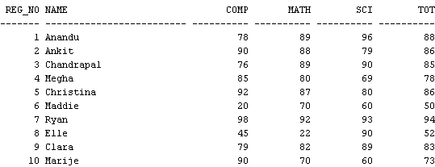

select reg_no,name from student

where math>25 and comp>25 and sci>25;



select reg_no,name from student

where math>=90 and sci>=90 and comp>=90;



select reg_no,name from student

where math<25 or sci<25 or comp<25;



select comp,math,sci from student

where tot between 70 and 80;

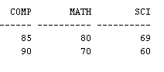

select comp,math,sci from student

where tot>90;



update student

set math=99 where name='Maddie' and reg_no=6;

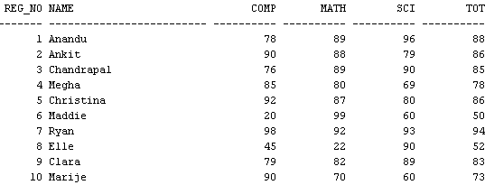

truncate table student1



drop table student1

